Greetings again from the Solomon Islands. In recent weeks the SWIM community has been busy with various ministry and outreach programs and SWIM teams, so here is a quick snapshot of just some of our recent projects -

**SWIM TEAMS**

We have been coordinating a number of rebuilding works, with SWIM teams from Australia and NZ. The teams worked in partnership with local communities and the local Churches to try and build areas of greater self-reliance. Some of the following photos are from Taroaniara for a medical clinic which has received very little maintenance work since being built 50 years ago. The refurbishment involved new roofing, guttering and frame structures, new doors and windows, new plumbing and electrical wiring and of course lots of painting. We had great support from the local TAFE equivalent training centre (RTC) with 10 carpentry and 5 electrical students volunteering during the build process and the Anglican Diocese helped provide roofing materials and shipping transport of supplies. And while the teams worked on the buildings, we organised literacy and numeracy programs, and education supplies for the nearby schools. We also did ministry programs and youth outreach in the evenings.

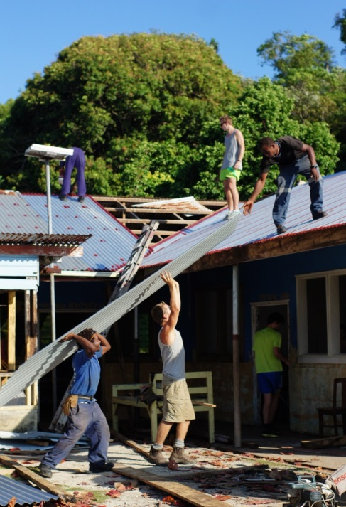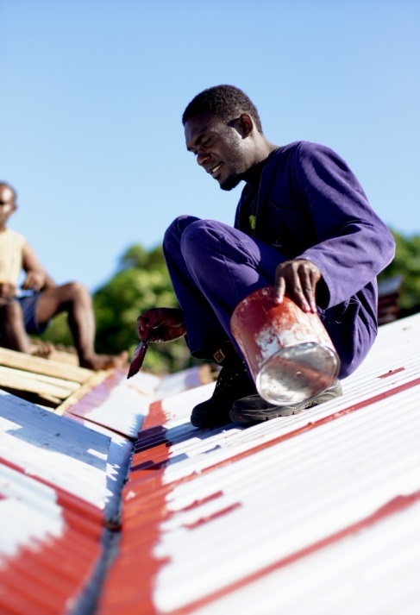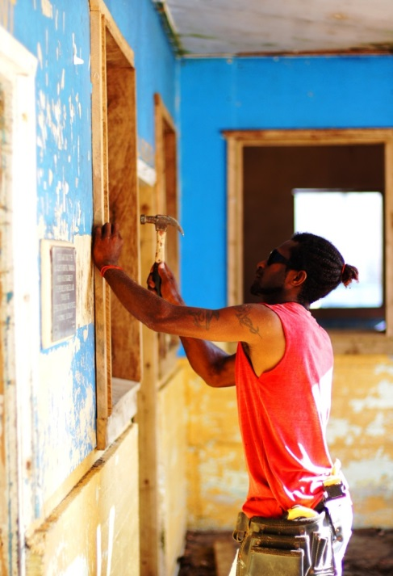

Some of SWIMs other recent projects have been working to improve education centres. West Side Christian College recently finished building and refurbishing some dormitories at a training centre in Kotave, East Guadalcanal. Lauretta and the Peet SWIM team went to Isabel province and donated iPads with fantastic bible story games and Christian teaching tools to help share Gods word in a digital format whilst addressing literacy and numeracy in a medium the younger generation can fully engage in. Despite these successes, there are still some really pressing needs here in terms of education – with teacher strikes and Government pay disputes accounting for close to 2 months of missed classes. **So please pray for the Schools, teachers and school students so as to bring an environment for improved learning.**

**PRISON MINISTRY**

In Cross Roads Bible study news, Rev Japhlet has transitioned into a new program with SWIM and the Prisons called Thinking Feeling Doing (TFD), aimed at using Gospel principles to mentor violent sexual offenders. An alarming survey has reported that Solomon Islands is one of the worst places in the world for gender based violence. Which is very disturbing for a population who proclaim themselves to be mostly Christian and we therefore recognise the vast amount of work that needs to be done in this space. So whilst we are glad for Japhlets new role we are desperately searching for a suitable replacement. In the meantime, Jair and Simon have been taking on this role in the Prisons, doing counselling and Cross Roads Bible program – which is both challenging and rewarding. **We would value your prayer that God will raise up the right person for the CBI role.**

**MINISTRY TRAINING**

Rev Eric Maefonea has had a very busy schedule with travel for ministry training in Rennell, Bellona and Malaita provinces. Primarily his focus has been on Christian leadership and integrity seminars and following from this, SWIM has been asked to participate in conducting leadership and integrity workshops with the Government public services – a fantastic opportunity! Eric has also been speaking powerfully this week in an evening ‘Honiara Crusade’ at the public market, which has seen strong support. Erics message was one of challenge to the Christians in this nation to be agents of change who have a fear of God. **Please pray for Eric and his family as he teaches and preaches throughout the Solomon Islands and for an impact by Christian leaders within the Government.**

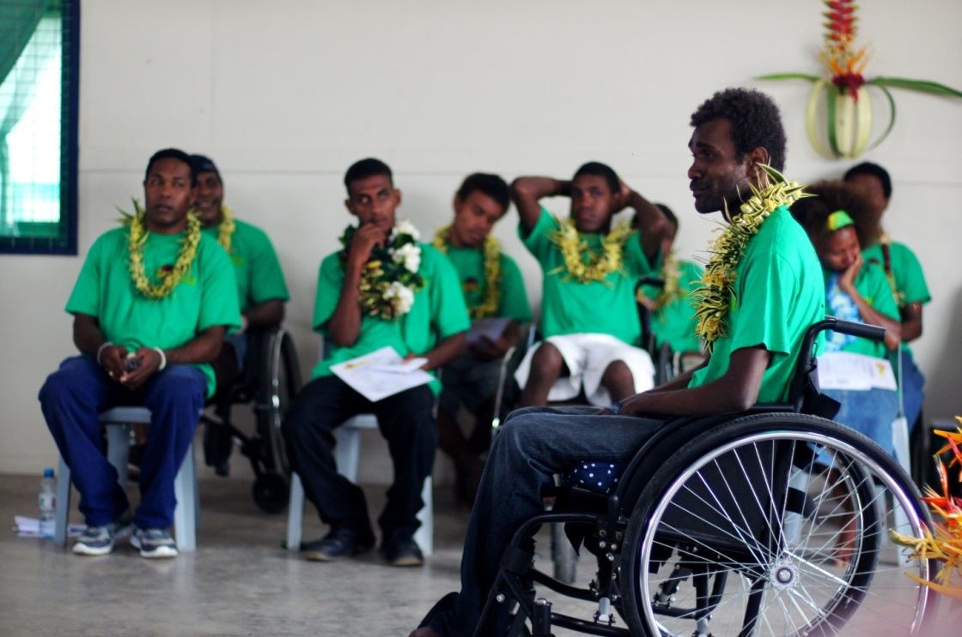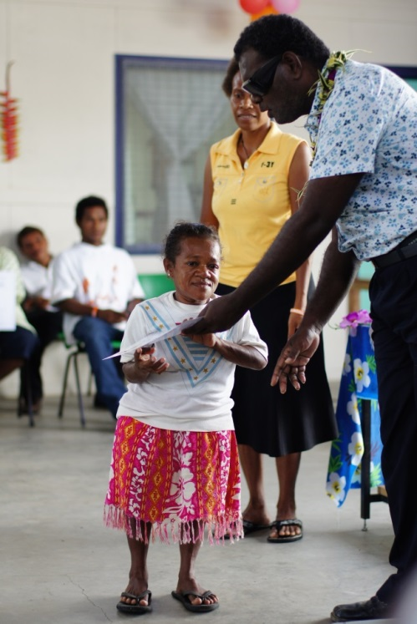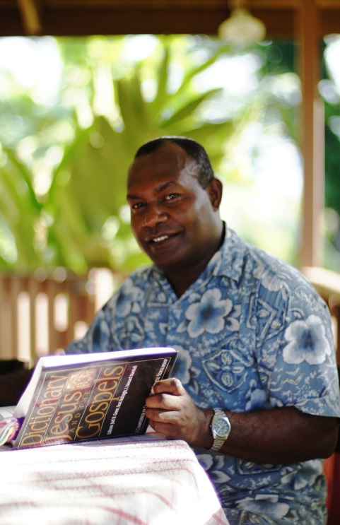

**BETHESDA**

Meanwhile, at **Bethesda**, the last student course for the year has just been completed. Principal, Gideon Row has been attending an RTC strategy and planning conference whilst Susan and her counterpart Chris now embark on a period of teacher training and planning for 2014s longer course structure. Ant and his new base manager Paul are involved in many continuing building and maintenance aspects and have had some success in applying for Australian aid funding for some new agriculture infrastructure. Ana has been supervising Community Based Rehab students in fieldwork and then trying to coordinate the course and develop curriculum. Ana has started showing the students one episode a week of *Joni and Friends*. This is a TV show produced by Joni Erakson Tada who became a quadriplegic at the age of 16, and now 35 or so years later has a wonderful Gospel message on how God cares for those with disability and injury. The show helps the students dream big about what is possible for people with disabilities and also challenges their beliefs about disability.

Finally, we have a number of containers sent across every year – and want to say a BIG THANK YOU to those who are involved in that! (A container just arrived from Tasmania with medical supplies and equipment which was badly needed.)

Thank you again for your support, your prayers and your messages. We feel honoured to be here as His ‘hands and feet’ in the Solomons.

God bless,

SWIM staff and families  
Honiara, Solomon Islands