Diary on my work in Pakistan

Monday 31st, Tuesday 1st.
I met Kamran at Melbourne airport as arranged and we got on our way without any difficulties. We entered the New Year somewhere on flight but then left it again, to enter it once more waiting in transit in Singapore. We managed to get a sleeping chair at Dubai airport but did not have much time to rest before setting off to Karachi. Entry into Pakistan gave no problems but the next connection to Lahore was in doubt because of mist. For a small sum we were able to wait in a transit room with Wi-Fi and refreshments until departure, which occurred on schedule despite warnings of delays.
At Lahore we were met by many of Kamran’s relatives and taken to the house of his brother-in-law, Ashraf, at Foreman College. This was a comfortable house on a secure compound of over 100 acres, and I was given my own room as Kamran had travelled on to his parents in Sahiwal. Ashraf was interesting to talk to, as he is the College’s bursar (?). He explained how the college had been taken over by the government but was won back for the church through legislation. They have over 6000 students, about 10% of them Christian. Anis, Ashraf’s wife, cooked a beautiful dinner, a chicken curry with chapatti.

Wednesday 2nd
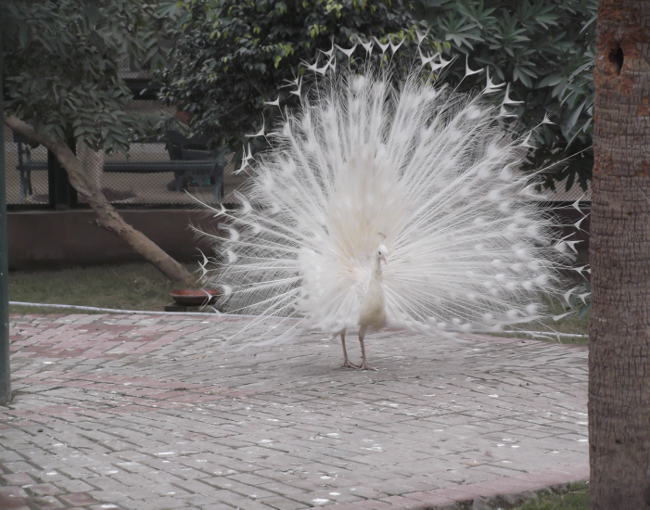
After breakfast Ashraf had his driver take us around to the zoo where we looked around waiting for shops to open (most open later in the day). We would have gone to see the historical sites except that it was unsafe, as people were meeting there for a Shiite holy day. It was very cold (between 3º and 8º C, even the locals complained it was much colder than usual), so I bought a leather jacket. This is proving to be a good investment, as houses are mostly unheated (sometimes there is a small gas heater, but the piped gas is not always available and usually lacks pressure when it comes on). The houses are built for the more prevalent heat of the other seasons and rooms do not seal you from the outside weather except for the wind and rain. As a result people dress the same inside as for outside, wearing coats and hats or, as is the fashion, blankets.
At the zoo
Kamran joined us again in the evening, and we got on-line to communicate with our families. Anis again cooked us a wonderful meal. As jetlag caught up with us we went early to bed.

Thursday 3rd
In the morning we got some sim cards. They were not much help, as mobile phones were turned off for a time for fear of terrorist bombers (they use mobile phones for remote detonations). Kamran and I were then taken to the shops by the driver, a helpful chap, who accompanied me shopping while Kamran got a haircut. As the power went on and off this took several hours and by the time we returned Ashraf was worried and told us off for taking too long. The driver was there to take us to Gujranwala Theological Seminary. Here we were received by the principal, Arthur James, who was clearly not very well. We were housed in half a building, two bed/sitting rooms with double beds with a bathroom between. My room has a desk to work on; Kamran’s has an asthmatic gas heater. Unfortunately there was no hot water and we could not get the water heater to light up (not enough gas pressure).
At 5.30 we had chapel, but were not introduced. The principal looked worse, if anything, and was clearly not up to par. The vice principal was also sick (and absent), as was the next in command. Even Kamran could not follow what was going on. After chapel we went to the principal’s house for tea, but he went on to see the doctor. We met another visiting teacher, Nassir, a Pakistani who taught maths in the USA before retiring. He is a pleasant man, but was not able to tell us much about what to do or expect, other than to direct us to come for breakfast next morning.
Kamran’s uncle lives just 500 metres from here, and we visited there for the evening. Another uncle was over from Britain, with his English wife and children. He took us to the local pizza shop for dinner and I treated everyone to an ice cream (the cold did not deter them).

Friday 4th
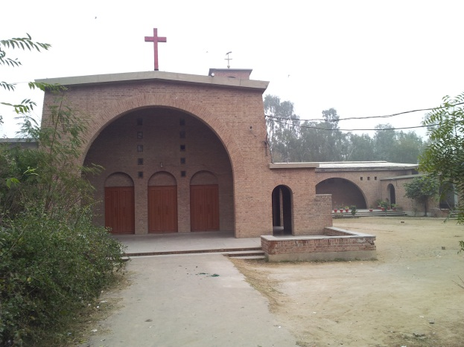
We had breakfast with the Principal who lives in a large house next door which also houses the single women on the first storey (they get locked in at night). He was sick in bed and we got no instructions from him. After breakfast we were asked to come to chapel, where again we were not introduced. Students led the devotion. Then I was suddenly told I would be teaching the next period. I had not been told what I was teaching, or how often or how long, and had nothing prepared. I spoke on Rom. 12:2 and used it to introduce the worldview course. Kamran translated. After 45 minutes class was over and another teacher took over.
The Chapel
We went to visit Kamran’s relatives and I was shown the house, a narrow two storey building with the roof serving as a third storey. There are no clearly defined areas, except for the kitchen, which is at one end of the bed/sitting room on the ground floor. This could also serve as a garage, as it has a strong steel garage door with multiple bolts and locks. There is a smaller door inside. After farewelling the visiting family I went back home and bought some drinking water on the way. I wanted to be off the streets before the Mosques opened for Friday prayer.
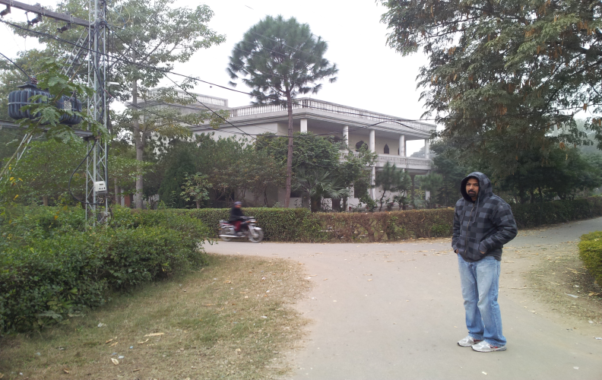
I had lunch at the principal’s house, and spent some time talking to Nassir. Here I also met one of the church leaders and prayed with him after discussing the state of Christianity in Pakistan. He could understand me, but used Nassir to interpret for him. He invited me to preach at his church the next week, but I believe Kamran has already made other arrangements for that Sunday. Then I went back home to prepare lessons in the hope I might get to teach them. I had a cup of tea with the student living next door, Ejaz, and met his wife and child. There was a wedding on the compound and I took some photo’s, but missed the bride as Kamran returned and we again went to the principal’s home for dinner. He was absent in his illness, so we still had little idea about what might be in store for teaching. We tried to light the water heater again, but without success.
The Principal’s house

Saturday 5th
Some dog decided to serenade us for most of the night. At least it encouraged me to try the water heater once more at 4.00 am, and this time it lit. Back in bed the serenade weakened, but just as the dog was tiring, and I was hoping I might get some sleep, the calls to prayer from the minarets took over. I did manage an hour’s sleep after they got tired but all too soon it was time to get up. The water heater had gone off again, but as I could not delay a shower any longer, I had to brave the water. This might have had had the edge of its coldness taken off, or maybe was that my imagination.
After chapel I was given the students again for almost an hour, but then had to make room for another teacher. I still have no idea what I can expect to contribute here. So coming home I thought I would start on this diary.
After writing the above I decided to get into bed to warm up. The temperature is constantly hovering just above zero and you can see your breath day and night both indoors and outdoors, except that indoors is usually too dark as the electricity only works intermittently. The windows are too small to let in much light and the days are short. But I fell asleep while listening to a talking book. Kamran had also fallen asleep and we must have needed it because we did not wake up till nine when somebody banged on our door to come and eat our dinner.
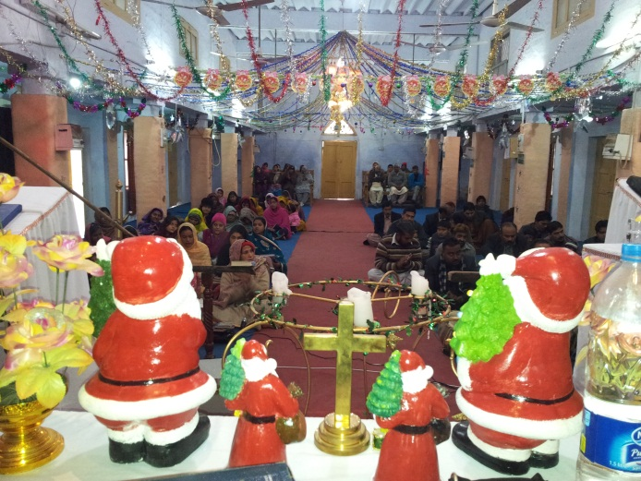
I stayed up late to light the pilot light on the water heater in the hope of taking a shower in the morning. However, that was a vain hope and I had to brave a cold shower as I wanted to be clean for preaching. One of Kamran’s uncles picked us up at seven and drove us to our destination, Lalamusa, a place some 80 kms on the road to Islamabad. He had a micro-mini bus, a 800 cc Suzuki, and his wife, son and daughter also came with us, a nice family. The pastor of the small Anglican Church was another of Kamran’s numerous in-laws, and his wife gave us breakfast while a bell summoned the parishioners. I was appropriately dressed in suit and tie, but I don’t think that showed as I wore my leather coat over it all to stop from freezing. When the congregation was seated, on carpets, we entered as young ladies showered us with rose petals. At the front we were decorated with garlands before being seated behind the altar, which was decorated with a number of large Father Christmases.
My view from behind the altar
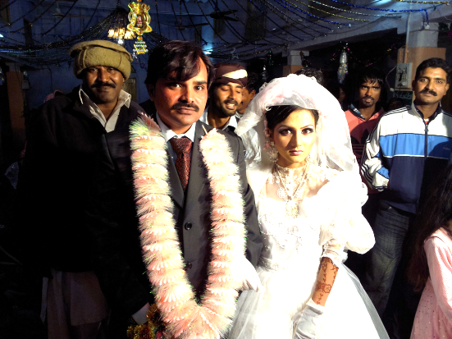
Despite the unusual setting the service was Christ centred and uplifting. There were several special numbers, including a song from the family that had accompanied us. The sermon I preached on the Rich Young Ruler was well received and it was clear from audience feedback that quite a few of the men did not need Kamran’s translation. After the message people came forward for me to pray over them, so that by the time I was done lunch was ready. This consisted of a bone marrow soup with chick peas and chapatti. I was just finishing when the pastor came in with another request, would I marry the young couple at the ceremony that was just starting. I barely had time to download the Anglican wedding vows (fortunately the pastor’s internet was working) before I was placed in front of the bride and groom and expectant congregation. I gave a brief message, followed by the vows and exchange of rings. Then I asked, “what now?”, as I did not think our customary kiss would fit in with the culture. I was right, instead of the kiss I had to invite the groom to see his bride by lifting the veil.
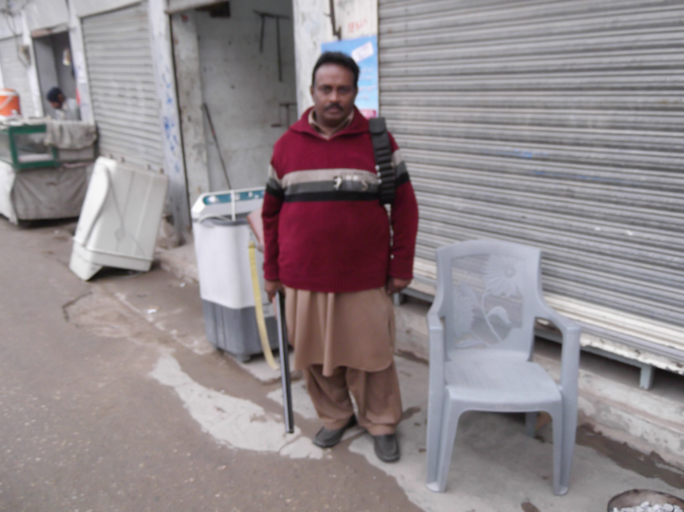
The wedding was a shotgun wedding, but not in the sense that we use the term. Seated at the gate was a guard with a double barrel shotgun, to guard churchgoers against any terrorist attack. Apparently he had also been on guard during the morning service. I examined his shotgun shells, and discovered that the pellets were about the size of blue berries, designed to kill and not just hurt people. Apparently armed guards at church services are standard protection. It reminded me again how difficult it is to be a Christian in this land.
We hurried home after the wedding to try and beat the fog (or rather, worse fog, as it is constantly foggy), and Kamran and I shouted our driver and family to a pizza meal when we returned to our town. As the electricity and gas were off we went straight to bed on returning to our quarters.

Monday 7th
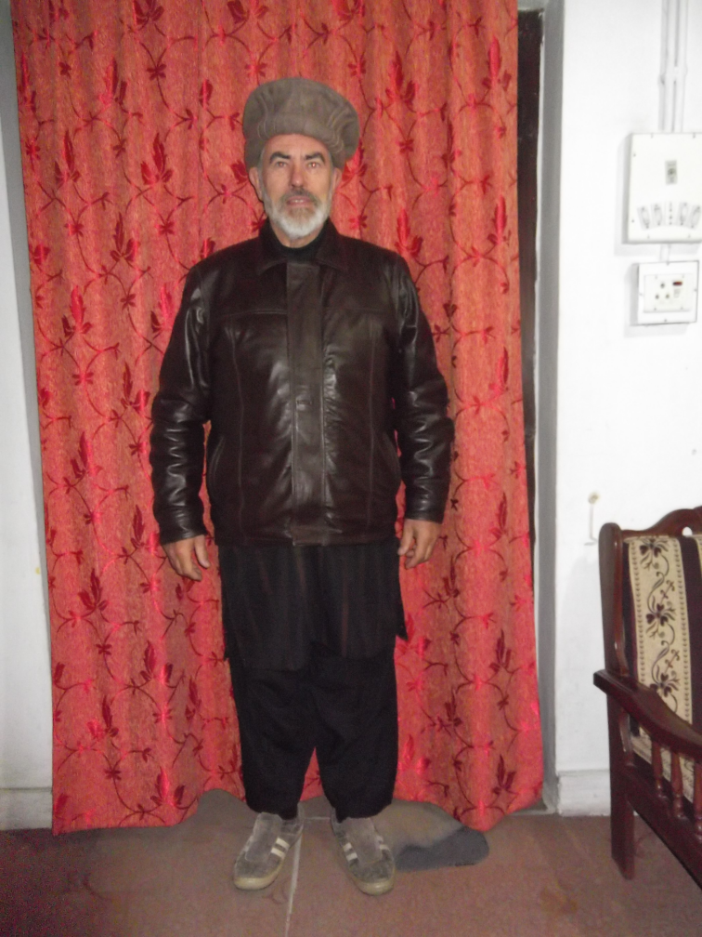
Monday is the seminary’s day off (as there are classes on Saturday). There was no one around for breakfast, but it turned out that it takes place later on Mondays. After breaking our fast we briefly visited Kamran’s relatives and then returned to do some work. But as my computer was discharged and the power was still off there was little I could do. It was even too dark to read. I am thankful for the talking book on my phone for moments like these, as there is little else to do. To my surprise the Water was hot enough for a shower. I had fixed the pilot light (the heat sensing cut-out switch has been wrongly installed) and the gas had come on. Sadly the shower did not warm me up, as the showerhead would have won first prize in any water saving showerhead competition.
Kamran has gone to buy a connection that will give us Wi Fi using our neighbour’s network. I went to lunch and was pleased to see the principal up and about. However I still could not get any direction on what to expect to teach.
This afternoon we got a Wi Fi connection set up, but the internet itself is down. I went out shopping with Kamran but for security’s sake I was advised to wear local dress. My clothing is from northern Pakistan since I resemble the Pathan people from there. I feel self-conscious, but it must be effective, as I did notice people looked surprised when I asked for the price of things in English.

Tuesday 8th
Taught two classes in the morning, then prepared classes for the next day. The cold has not let up. But the hot water worked, allowing me to do some washing. We briefly visited Kamran’s uncle, and Kamran returned there after accompanying me to the seminary. At night I sat around a campfire with some of the faculty, and had a good conversation with the principal. I learned he has written commentaries in Urdu on each of the NT books.

Wednesday 9th
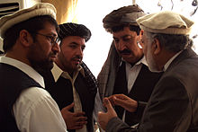
Finally we got to see the sun. It promised to come before chapel and came out when I started classes. After class I got a chair out and sat in the sun while reading a review book on worldviews. Later we borrowed a car to go to a shopping centre that is reasonably secure and also somewhat warmer (the temperatures outside had dropped to just above freezing again). I was dressed like a Pathan (Pashtun) from the North of the country, and was obviously accepted as such until I opened my mouth to say something other than shukria or tiga (thank you, OK).
Pashtuns
I bought a shalwar kameez (an outfit like pyjama pants with a long tailed shirt) for saver travel. My companions insisted on it, though I wonder if it is a bit of overkill. But listening to the news today, which mentioned planned demonstrations in Islamabad over the weekend, maybe they are right. Reportedly a leader is bussing in supporters using 40,000 busses. Even though he is a moderate, this could get ugly. We are scheduled to go there, but if this develops we will have to change our schedule. A pity, because the trip to Islamabad was supposed to give me a view of the Himalayas.
When shopping I bought a woollen jumper, much warmer than my cotton gear. Prices are cheap. I saw the same shoes I examined last week at Harris Scarf, where they went for $120 a pair, selling for just $27. I bought a nice pair of warm leather Hush Puppies for $26. Kamran bought whole outfits for himself and his family at home. We also bought some clothing for the students who were transporting us. After shopping I went back to our quarters, but Kamran stayed overnight with his family.

Thursday 10th
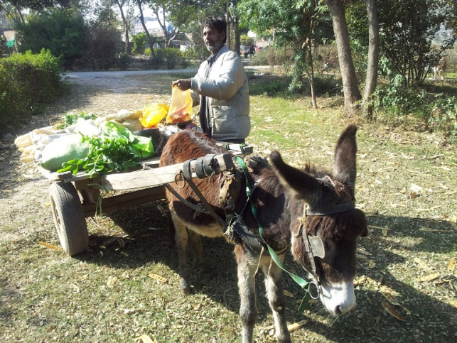
No classes today, which gave me a chance to prepare some more lecture notes to hand out to the students. Because I have been given limited class time I have to dilute (and simplify) my notes from the RTC. The green grocer came past, with his donkey cart. I also took some photos around the compound, which looks much better now the sun is out. The sun does nothing for night time temperatures, and I am typing this with all my clothes on, including gloves, wrapped in a blanket. This causes plenty of spelling mistakes which need to be corrected.
In a few minutes we will go next door to dine with the family of one of the lecturers.

Sunday 13th
Not much happened other than classes in the morning the last two days, except that plans to travel to Islamabad did not work out for me. The problem is a political “big march forward” planned for the next few days, with a politician renting 20,000 busses to carry people to Islamabad for a march on the government. The latter, in turn, have put up road blocks and turned off mobile phone relay towers. Kamran left to try and get through anyway, as we were scheduled to preach near Islamabad, but it is too risky for me. I just attended church and then sat in the sun. The weather is a bit warmer now,

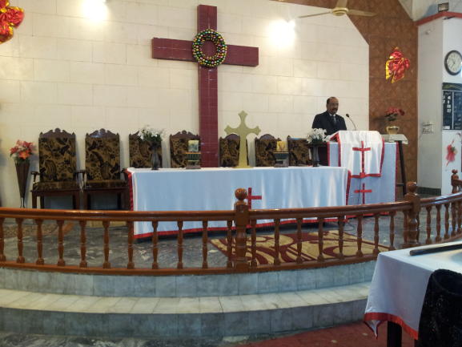
Monday 14th
Kamran got as far as Islamabad but not to the church. I got a phone call to say he was in Lahore, because the only transport out for him was to fly out. He hopes to be here in time for class. I am feeling a bit queasy and hope I will be up to teaching tomorrow.

Tuesday 15th
Taught classes today, but did not feel so well. Stomach was playing up and I felt a bit dizzy. I could not take any food when we were invited for brunch at the neighbours, though it looked tasty. Think I’ll go and take a rest.
Service in the Presbyterian Church

Wednesday 16th.
Threw up and more yesterday, really upset my electrolytes and felt very crook. Saw doctor who diagnosed amoebic dysentery and prescribed medicines, a diet, and rest. I do wonder about some of the medicines, as one local product promises to cure everything from baldness to haemorrhoids, but at least one medicine comes up on the internet as suitable for dysentery. Typing this will be all the work I can do today, then I will rest before we move on to Lahore

Thursday 17th
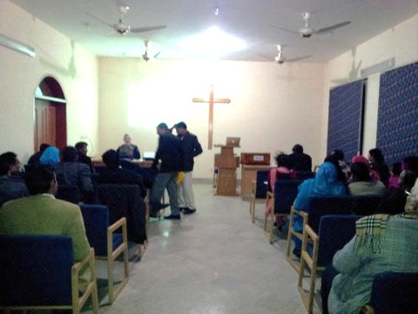
We arrived at the Open Theological Seminary last night. I was done in and went straight to bed. At least I had a comfortable room. I gave four talks at the OTS today, and Kamran led a devotion. The Students were very keen, with many questions. There were about 35-40 students altogether, about a third of them female. They mixed them in discussion groups, which is not quite cultural, but made for lively discussions. We also had lunch together.
The place here is well laid out and the rooms are comfortable. One of the staff cooked dinner for us, but would not let us out of the door after dark. He himself went to buy me some more medicine as my tummy is still very uncomfortable. Fortunately in teaching I could use my PowerPoint programs which allowed me to stay seated.
Lecturing at OTS, Lahore

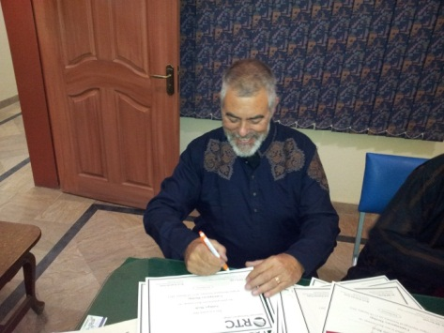
Friday 18th
I gave three more lectures and handed all the students a certificate stating they had participated in the seminar. The organisers had pulled the RTC logo of line, and the certificate was in the name of the RTC. Since it only specified attendance I guess principal Capill and the Board of RTC will be okay with it. We will travel on to Sahiwal later today to stay at the ARP mission station.

Saturday19th
Last evening I was welcomed by the former New Zealand missionary, Frank van Dalen. He is now in charge of the mission program, and frequently visits here from the USA. I felt a bit better on waking up, and a western breakfast helped. Frank mentioned he would arrange for me to be registered with the police, a necessity in this town, but not too strictly followed in other places. After that we went to address the teachers of the three Christian schools in the region. These turned out to be mostly young women.
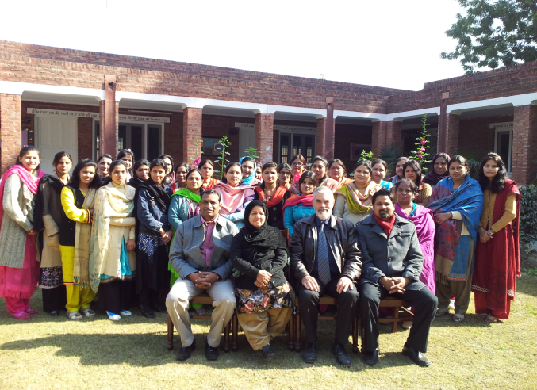
Kamran led the devotion, and just when I was about to start I was summoned to the police station. However, the process was very smooth, and I was back in 15 minutes. Since my presentation had some discussions Kamran had them started on these, which worked out very well. I spoke on calling and vocation, and some of the pitfalls in choosing a vocation. I ended with encouraging the teachers to lead their students to a godly vocation. It was well appreciated.
After lunch I dealt with the topic of life after death. In a context of persecution and little wealth this again fell on appreciative hearts. There was also considerable confusion on the topic, mostly because of ideas syncretised with Islam. Thus heaven was conceived of as a paradise, not a New Jerusalem. And it was clear that many thought that one got there through works. In view of the antagonism of Islam I am amazed there is so much syncretism. It helps me understand why the theology of the last part of the first millennium, when Christian and Muslims rubbed shoulders, has so much in common with Islam (salvation by works, syncretism).
With the Christian teachers
Later Frank took us across the road, from the mission compound to the hospital compound. Because this is known as the “American hospital” an armed guard led us across the road. All the gates have armed guards, with shot guns, rifles or fully automatic weapons. Thankfully neither compound has ever been attacked, and the police appear to be doing a good job. There is a higher percentage of Christians here, maybe as high as 5%, and the leavening effect of the Gospel can be clearly observed here.

Sunday 20th
After breakfast the power was on, and I was able to Skype the family as they were gathering to say goodbye to Ana. She is on her way to the Solomon Islands today. I only had a brief talk because my computer battery ran out, and there was no socket near the WiFi hot spot. In any case I had to get ready for church. I preached in one of the town’s dozen or so churches. About 5-8% of the town is Christian, but there is a lot of nominalism. I was disappointed with the attendance as I had heard there were about 80 Christian families in the district where I preached, but the attendance might have been around 100, with mostly children. I was told that three funerals in the past week might have contributed to this low attendance, as people consider themselves unclean after attending a funeral (Muslim syncretism again).
Having said that, the people there gave us a rousing welcome, singing their hymns with gusto. There was a high watt amplification system and the volume would have done an Aussie disco proud. The fact that I sat right in front of the big amplified base drums did not help me. When the power went off I was about to sigh a prayer of relief when I heard the generator starting, which turned my prayer from an intended “thank you” to a “please, Lord”.
As my ears went numb I began to detect the underlying lyrics and discovered the refrain consisted of words that were easily learned. I softly joined in, but then, as I remembered being blasted out of my sleep every morning at 5:30 by the mosques, I began to sing with equal fervour.
I preached on Ps. 49, using the message of Christ’s ransom of sinners to point to the freedom of God’s grace. There is a lot of salvation by works theology here, and I even heard people say they expect to see some of their Muslim neighbours in heaven because they are nice people.
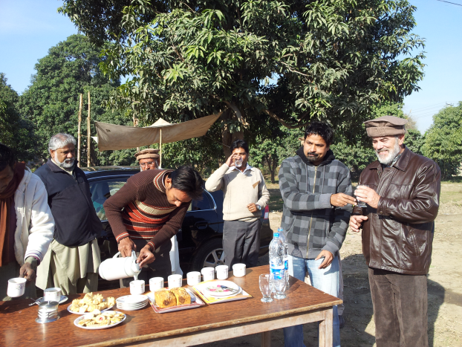
After church we had chai (tea mixed with herbs, milk and sugar) with the pastor and then went to visit Kamran’s parents. They are a lovely godly couple who spent their whole life doing the Lord’s work. His brother-in-law then took us out into the countryside where he part owns a farm with two other brothers. I was very impressed by their irrigation system. They use the power train of a tractor to run a bore hole pump which fills small canals with beautiful, and remarkable clear, water. They had lots of young wheat plants coming up, and some small clumps of vegetables like turnips, radish, garlic and herbs, including mustard. In the village their compound had some cattle and chickens. Everything appeared to have a use: scraps went to the chickens, wheat husks were mixed with greens for fodder and the cattle dung was dried for fuel.
Back at the mission compound we went to John Justin, head of the schools, for dinner, a lovely BBQ with chicken, naan and salad, followed by ice cream. They have some great ice cream here.

Monday 21st
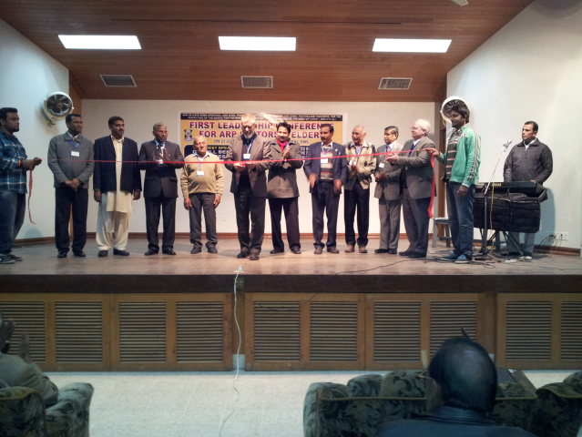
After a lazy morning we began the pastors’ retreat that was one of the main reasons for my coming. The event was held in the Christian hospital conference room, a well set up facility with a stage/lecture platform and ample seating. The opening was very formal. There were garlands and lots of speeches and I had to cut a large red ribbon to open the event. Kamran did the opening devotion and I presented my first lecture using the PowerPoint program I had prepared on the biblical teaching on the Trinity. It was well received and clearly much of the material was new to them. There was a good discussion time after.
Opening the pastors’ conference

Tuesday 22nd
We met again, starting a little later in the morning to allow others to travel in for the day. While there were only 98 people in all, out of a potential 150 or so, the important thing is that this was much more than the local leaders had anticipated. One thing I have learned is that, sadly, there is a lot of infighting among the leaders, with many court cases pending over property rights. For this reason I really impressed how the Trinity is a model for Christian unity, in the home, the church and the wider Christian scene. Again there was a good discussion, in small groups, after the lectures.
After lunch, by popular demand, I dealt with millennial issues and what we can expect on Christ’s return. There is a lot of confusion on the subject, and all the western fads on the topic appear to have reached Pakistan also. A solid biblical presentation was much appreciated, especially the hope that it gives in the promise that Satan cannot keep on deceiving the nations. Premillennialism leaves people very pessimistic about Pakistan’s future, and postmillennialism is just not on the horizon here. But the amillennialism I presented found hopeful acceptance. They were especially encouraged by examples of other countries, traditionally closed, that had opened up to the Gospel, like Mongolia and China, not to mention the rest of the communist block.
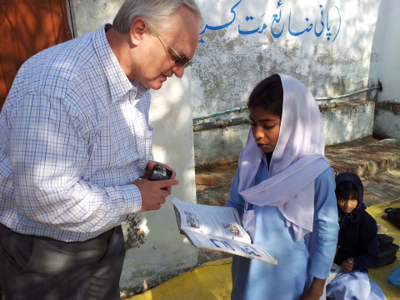
It was nice to have a comfortable evening at the mission station and swap stories with Frank van Dalen. He mentioned how Henny and my mission deputation tours in New Zealand had been an ongoing encouragement to him to go into mission, though like with me, the Lord had used Minka Hanscamp for the initial prompting.
Frank van Dalen inspecting student’s work

Wednesday 23rd
We hurried back to Gujranwala, where the students had meanwhile sat their test in Christian Worldview. We picked up another of Kasmran’s ubiquitous family, a brother-in-law studying apologetics at Oxford. Maqsood is a very able scholar and delightful person to converse with and we discovered we had many things in common.
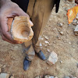
After catching up with everyone, and briefly joining the students in a game of cricket (where Kamran’s batting was much more impressive than mine), we treated the principal and his family to dinner, as they has cooked for us all the time we were there. Dr James is a real man of God, but of the old school, and not very flexible to new approaches (like intensives). We were happy to hear that he would have the college driver take us back Sahiwal tomorrow.

Thursday 24th
I have not had time to fill in the next few days until later. The trip back was smooth, except that the radiator overheated. It was great to have a nice hot shower again. Frank has returned to the USA so I had the place to myself.

Friday 25th
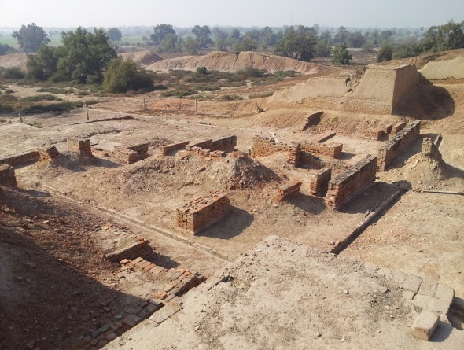
Today we took a day off and went to see an archaeological site marking a phase in the Indus civilization known as the Harappa culture. It goes back to 3500 BC, which must have been soon after the dispersion from Babel. Certainly the building style would have been very similar to what was used at Babel and the Middle East. I pulled the pottery shown on the picture above from the lowest layer, which probably means it predates Abraham. Unfortunately, since it was yet another Muslim holiday, the museum itself was shut. But the ruins were fascinating. It makes you realise that the brickwork you see everywhere has a very long history.

Saturday 26th
This morning we had the scheduled “youth rally”. There were well over 300 people present, but more older people than youth. I was told these older people were youth workers. I was asked to speak on amillennialism again, as this presentation gave hope for the future of Christianity in Pakistan. It went well, but unfortunately there was not much time for my closing devotion on being on fire for Christ, as the formal opening had taken some 45 minutes. The formal closing also promised to take a long time, though we had to leave early to catch a ride to Lahore.

Monday 28th
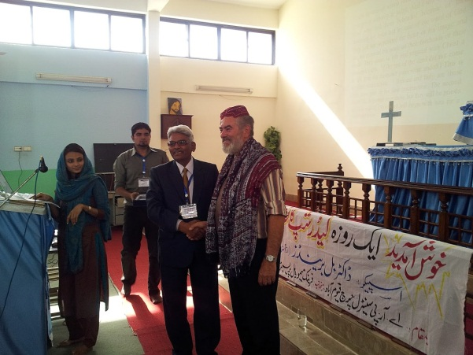
Unfortunately we had no opportunity to attend church yesterday as we had to catch a flight to Karachi. On arriving there we were taken to the Campus Crusade compound. Karachi is a large metropolis, but also listed as one of the least safe places to stay. Last night Kamran went out with some relatives and they watched an armed robber commandeer a car. I prepared for the lectures this morning, which, after the inevitable long, formal opening, went very well.
The churches here have to keep a low profile, and security is always an issue. I counted about a dozen “scouts” responsible for security during our meeting. The meeting was kept short for the same reason, it doesn’t pay to give the enemy a chance to find out what is going on. I noticed that the Christians here tend to live in ghettos that give the impression of squalor and poverty from the outside, but with houses that are quite reasonable on the inside. I believe this is a deliberate ploy, to escape attention.
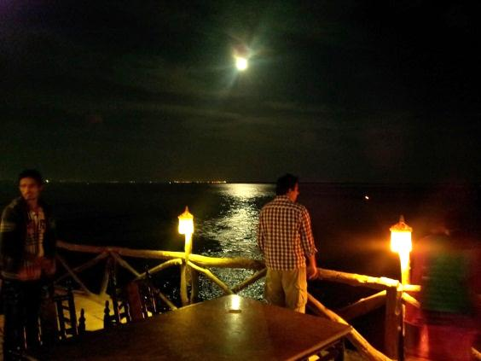
Despite the security issues we decided to see something of the Karachi that evening. We invited those who had helped us with transport and housing to a restaurant on the shoreline. I suspect the beach looks better at night, because pollution is a major issue in the towns. Despite our need to get up at 3.00 am to catch the plane home we extended our evening. The food was good, and the dinner provided an opportunity for a lengthy farewell (these things are never done in a hurry here).

Wednesday 30th
Home at last. We arrived an hour late, but I was able to phone Henny during the flight to warn her, and she passed the message on to Rubina, Kamran’s wife. Even so Henny and Rubina had to wait over an hour as it took that long to clear the formalities at the airport.
Was it all worth the while? Yes, certainly. Constantly we were reminded of how cut-off from other Christians those who live in Pakistan feel. Time and time again we were told how much they were encouraged by our visit. There was a plea that our visit should become an annual event. I could not promise that I could come that often, but promised to encourage others to consider visiting.
I hope to follow this up with an assessment of the needs of the Pakistani churches and suggestions as to ways in which we might be able to help them. But for now I want to thank all of you who helped make this visit a possibility through your generous gifts. I will give a full accounting of how the money was used to the RTC board – feel free to contact the RTC office for information.

Bill Berends

