**Myanmar Ministry Update**

**March 2013**

The Christian Reformed Church in Myanmar has been bringing wholistic transformation both physical and spiritual through implementing programs to help, strengthen, and to transform the lives of people to the most needy people. Over the past twenty eight years the church has been working hard to bring transformation to the rural communities in southern part of Chin hills. We are thankful to those who pray for this ministry and support the works we have to carry on to the glory of God.

1. **The 28th General Assembly**

The 28th General Assembly of the church was held in Matupi, from February 27 to March 2, 2013 at the Immanuel Christian Reformed Church, Lawngvan, Matupi. The motto of the Assembly was “Finishing Well,” based on Ecclesiates 7:8 “The end of a matter is better than its beginning.” Four pastors preached every night on the same text from different perspectives. There were more than fifty deligates sent from ten classes. The most discussed at the Assembly was, Home Missions, the need of the pastors in village churches, women work and Sunday School programs. Only one probationary pastor was ordained, and he is currently the principal of Reformed Theological College. At least six local churches need the pastors.

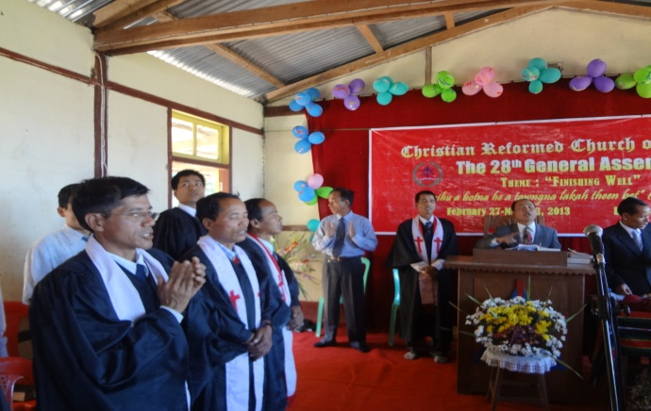 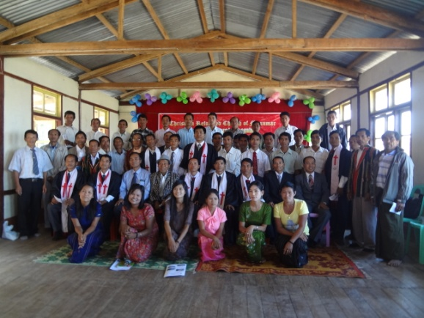

1. **Reformed Theological College 13th Graduation**

The 13th graduation of Reformed Theological College was held on February 9, 2013 at the Headquarters of the Nazarene Church of Myanmar, Insein, Yangon. Four students were awarded Bachelor of Theology degree and another four of the students were awarded Bachelor of Ministry degree. The graduation message was delivered by Rev. Dr. David Wong, senior pastor of Zion Bishan Bible Presbyterian Church in Singapore.

We are thankful to the Lord for his guidance and provision for over the past 16 years through the encouragement and support of God’s people from the United States. Reformed Theological College has produced more than 90 graduates and many of them serve the Lord in Christian Reformed Church and other denominations. The aim of the college is to equip men and women for the ministry of the Kingdom of God as pastors, evangelists, Bible teachers, Sunday School teachers and church workers.

Due to the limitation of the class rooms, living room, and library etc. the college can admit not more than ten new students every year. We have been praying for a permanent and enough spacious compound for the college so that we can have enough places for class rooms, library, living rooms, teachers room etc. and the college can admit more students to train for the ministries of the church.

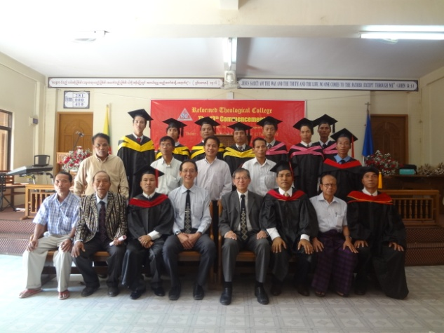 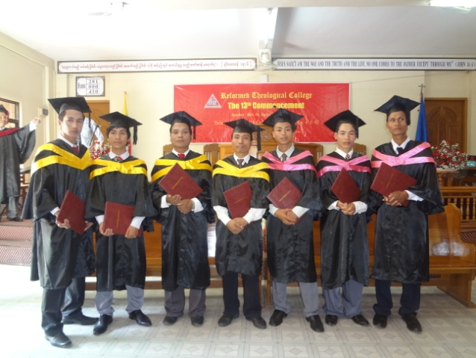

1. **Siloam Clinic and Health Ministry**

Over the past 16 years through the help of the Luke Society Inc. the medical missions among the most needy and undeveloped rural area in Matupi in southern part of Chin state. The medical mission has been working hard to improve the health of mountain people and to improve rural community development. As the ray of freedom and democarcy emerging in the country we hope that the medical missions of the Luke Society in Myanmar will grow to touch the lives of more people in the future. Although the health condition of the remote mountain people before the Luke Society medical mission began in the region was very low, through working hard of the health workers of the Siloam clinic the health condition of rural people is much improved. In addition to every day except Saturday and Sunday, the health workers are treating the sick people at the clinic and occasionally they went to visit villages and held basic health education trainings.

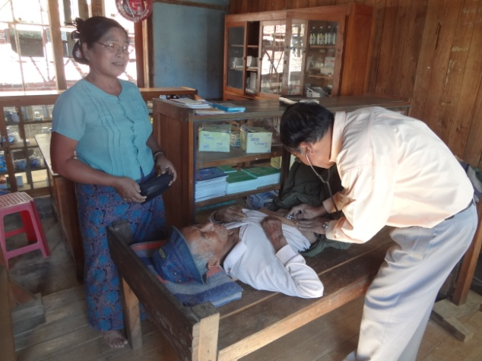 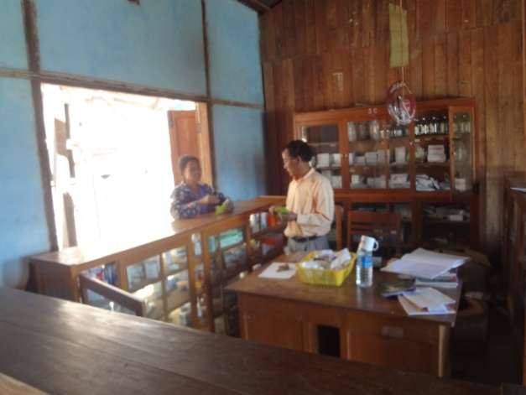

1. **Hannie Memorial Center**

Hannie Memorial Center construction started in 2009 in remembering of Hannie and her starting Women Fasting Prayer ministry in the Christian Reformed Church of Myanmar. The construction work was several times stopped by the former military government in addition to shortage of building fund, and building materials transportation difficulties. The construction work was not going smooth as we desired. One third of the construction work done by voluntary labor from the church. We expect that the construction work would be completed in May 2013 except painting and electrical installation. We are so thankful to those who generously gave fund to accomplish the construction work. The building has four storey including ground floor and it will be used for the ministry center of the church, Siloam clinic, prayer center, libary and book store, etc. I helped construction work while in Matupi for four days helping the mason who is one of Hannie’s nephews. Please continue to pray that the construction work maybe done in May including painting and electrical installation.

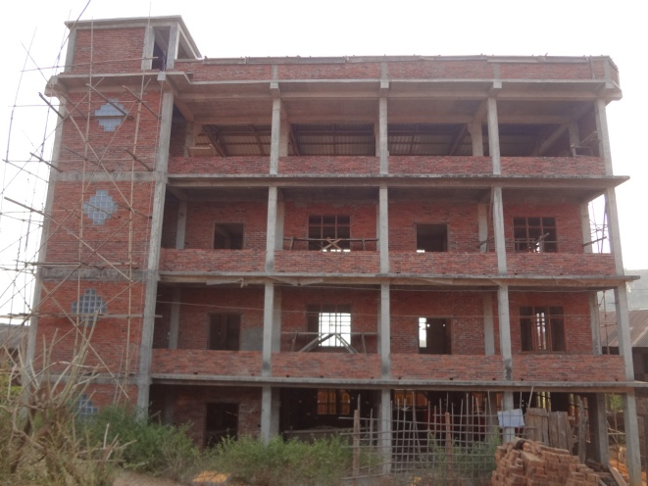 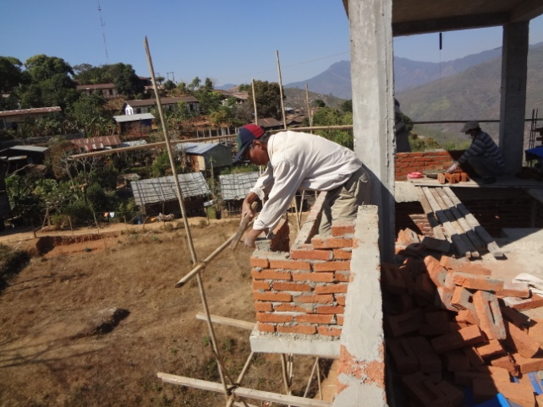

1. **Dry Rice Holes Projects**

I went to the site of highland dry rice holes project with Mr. Pathun the agriculturalist. He is planning to do different way of planting dry rice. Because of weed problems in rice holes, he will make mounting lines to plant dry rice. It will make easier for weeding. Legume trephosia grows well. Artemisia germinated well but after growing a foot tall they began to fade away. Amaranth germinated well by they do not grow tall, maybe it is not the season for them. He will try to plant them in June again.

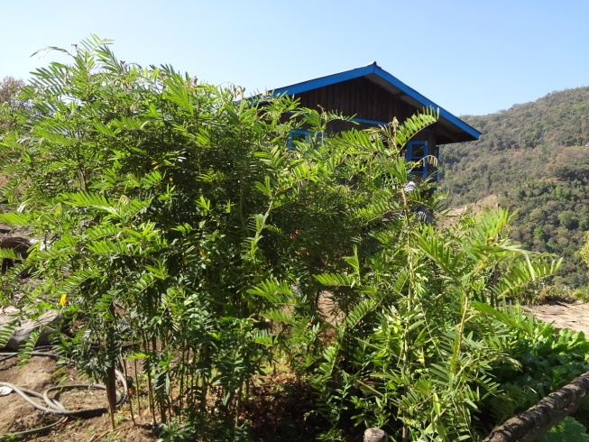 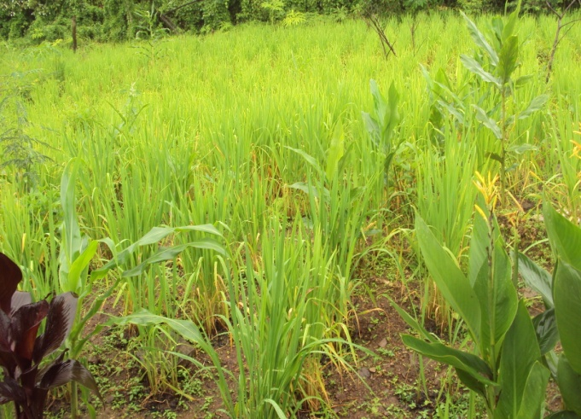

1. **Orange Groves and Teak Plantation Project**

Orange groves are planted in three different places hoping the proceeds would be for the mission work of the church. Orange trees grow well and bear fruits. But they are in remote area and has no access to the market. From last year 2012 villagers have been making roads voluntarily to connect one village to another at least five feet wide so that villagers can go from one village to another easier by China made motor cycles they can buy very cheap. Orange trees are starting blossoming again and I hope next year oranges can be shipped to the market place. Teak wood, in the past, owned by only the government and not allowed to plant or cut by any person. The government made a lot of money from teak wood. But now the new government allows its people to plant their own teak wook for their own income. I thought that planting teak wood will bring income for future generation and for mission works. We plan to plant teak wood from June this year. Arrowroot plantation is being carried on in every village for families and for the mission work of the church since 2011. Arrowroot are ready to sell only after three years of plantation. Dried arrowroot bags are bought by the Japanese and Chinese business men and this helps the villagers for their income.

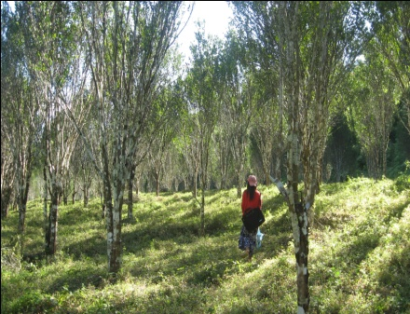 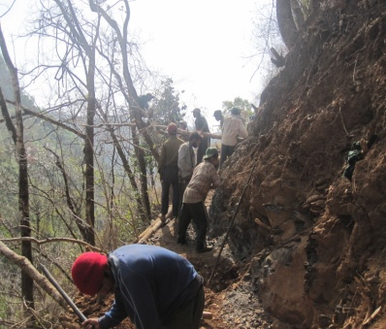 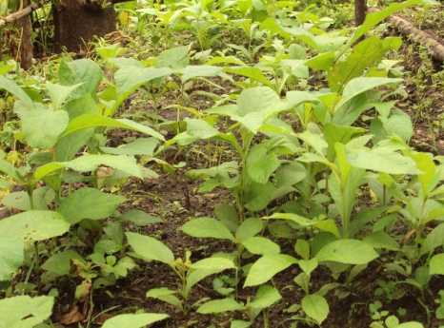

1. **Matu Christian Literature Project**

By the grace of God some Christian literatures have been produced or translated into Matu for the Matu Christians. Several Christian literatures are being translated and written for the Matu people. I myself have written or translatated not less than ten Christian books into Matu including Matu Holy Bible. Systematic Theology in Matu has been prepared and will be printed soon with generous help from friends in the Lord from United States. Burmese and English are taught in school but not Matu and the Matu have to teach their people how to read and write so that they can read Bible and other christian literatures. The Matu communities speak only Matu and not Burmese nor English. The Matu Christian Literature Committee is trying to help the children of Matu to teach them how to read and write. It is intended to teach the Matu children of about 25 villages in this summer. Matu Readers have been prepared by myself and some young people are willing to teach the children. We need note books, ball pens, and teachers support for two months. We shall be grateful if there is any organization or ministry that can help this need. Please pray for the children of Matu who do not know how to read and write Matu that they will be able to read and write.

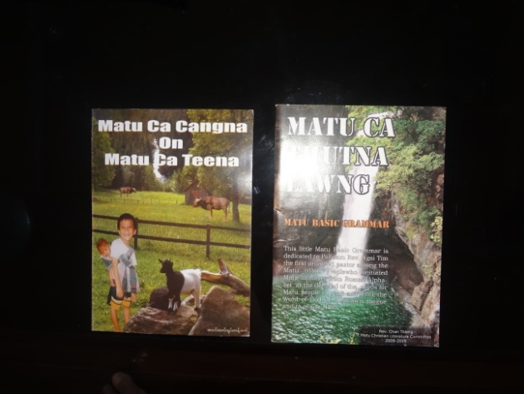

Thank you for your continual prayers and support.

In Him,

Chan Thleng

General Secretary

Christian Reformed Church of Myanmar