**You’re invited to join an RTC Study Tour to Israel and Jordan**

Have you ever wanted to explore the lands of the Bible first-hand? An opportunity to do just that is available now.

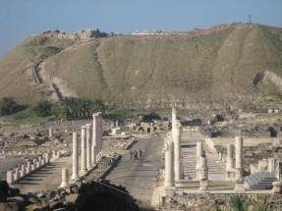The RTC is planning a student study tour to Israel and Jordan from 17 Nov to 6 Dec 2013, and there are still some places available for others. You can join with our Old Testament Lecturer John de Hoog and a group of keen students as we travel to many of the places where Israel and Jesus lived and worked, including seven days in Jerusalem.

Full details of the 20 day itinerary are available at <http://www.missiontravel.com.au/rtc2013>. It’s a very exciting itinerary.

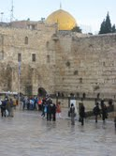A trip that offers so much is not cheap, but the cost of $6,499 includes all airfares, 18 nights 4 star hotel accommodation in twin rooms (with a single room supplement available), all breakfasts and dinners, and most other expenses for a twenty day trip (see the full list at the end of the itinerary). Also included will be a study guide that we will produce for students to help you make the most of this trip. A fair bit of walking is involved for many of the places we will visit, but you don’t have to be super-fit, just independently mobile.

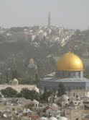

We have had some advice from an accountant that it will be possible (in Australia at least), with some minor paper-work, to claim the expenses of this trip as a PD experience for people in Christian ministry, so making it tax deductible.

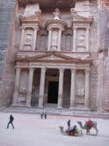

It’s going to be a great experience. The images included on this invitation are photos John took on a trip to Israel and Jordan in 2012. If you are interested in joining us for this trip, please contact the RTC without delay.

Contact: John de Hoog, [jdehoog@rtc.edu.au](mailto:jdehoog@rtc.edu.au), or phone 03 5244 2955.