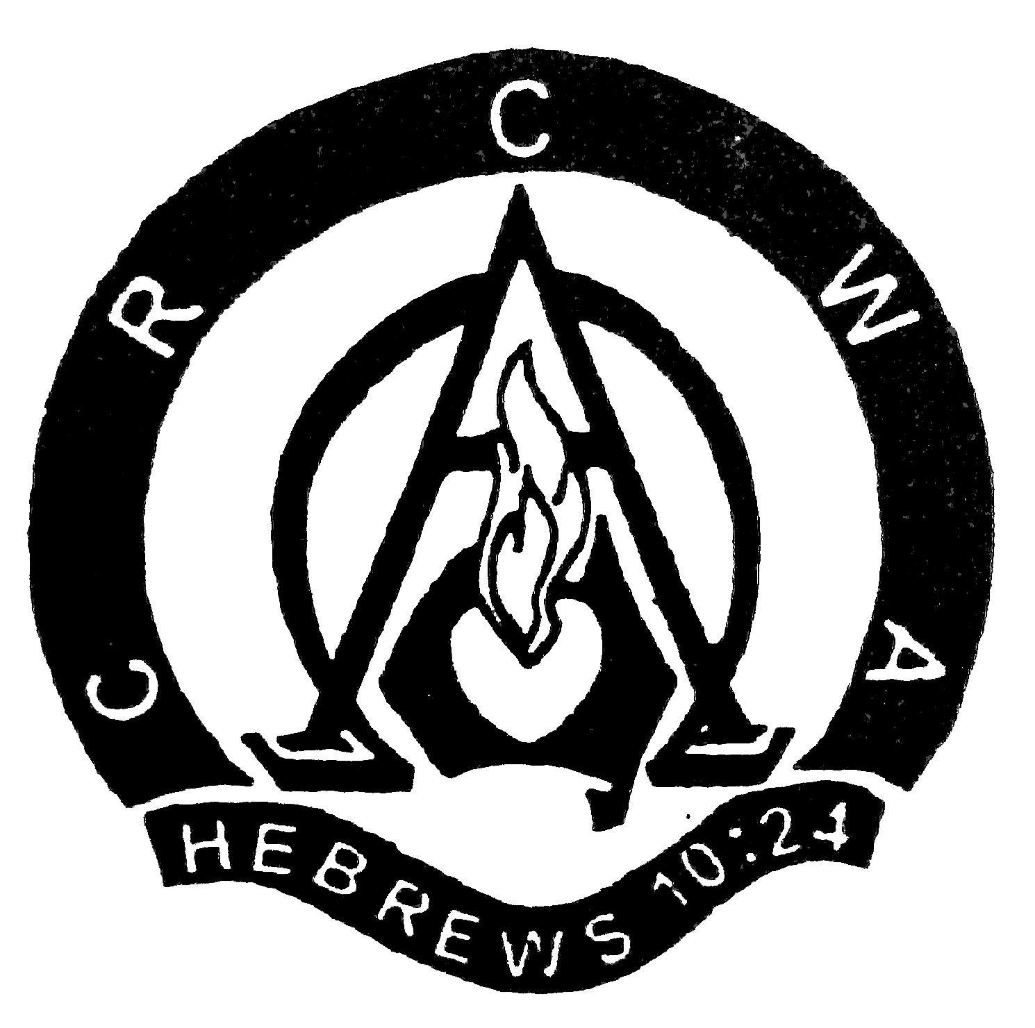
Ladies Fellowship Day

Advance Notice -

Due to Seniors Week and inavailability of speakers,
this year’s Ladies Fellowship Day will be held on
Saturday 26th October 2013
10am – 3pm
at the Christian Reformed Church of
South Gippsland
in Leongatha

